A1117 Afr-Egy-19th Dynasty-Ramesses II-1303-1213 BCE-stele

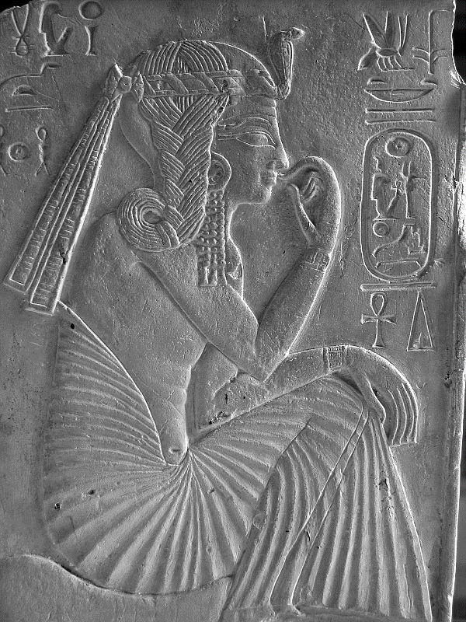 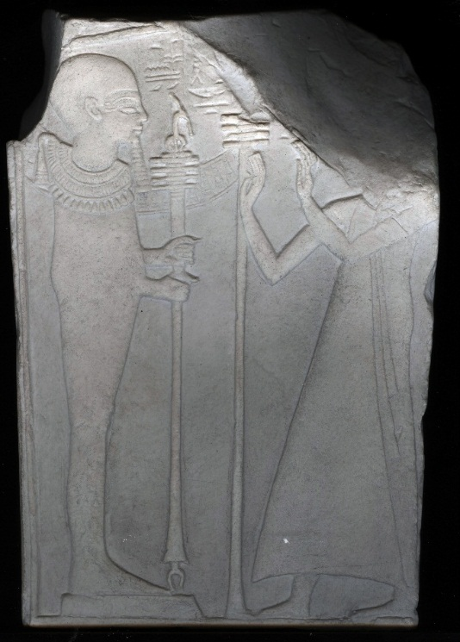

Fig. 1 Left: Obverse (front) stele of young Ranesses II; Fig. 2. Right: Reverse (back) Ptah and vizier.

**Case No.: 2**

**Formal Label: Stele of young** Ramesses II-1303-1213 BCE.

**Display Description:**

Ramesses (the Great) or Ramses (ca 1303-1213 BCE; reigned 1279–1213 BCE), 3rd pharaoh of the 19th Dynasty, is regarded as the greatest and most powerful pharaoh, who, with an army of 100,000 restored possessions in Libya, Nubia and Anatolia (Gabriel 2003: 6). This 18 cm carved stele was found in his original burial place, tomb KV7 in the Valley of the Kings but Ramesses II’s body was reburied 223 years after his death in the tomb of Pinudjem II (High Priest of Amun at Thebes, 990-969 BCE ruler of Upper Egypt) because of looting. He was considered as one of the descendants of Seth (Osiris’ slayer) because his hair was red as was that of Seth, and that of his father’s (Seti I’s) as well (Brier 1994:153). Today Ramesses II’s mummy is in Museum of Egyptian Antiquities, Cairo.

Both sides of this small stele in the Louvre are sculpted.

On the obverse (front side), young Ramesses II is identified by his royal cartouche. 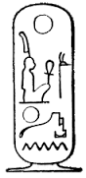

Fig. 3. Ramesses II cartouche.

Ramesses II is depicted with a single braid falling to the right side of his head and with a Uraeus (sacred cobra) encircling his head as protection. He is seated on a cushion, with a beaded earring on his right ear and with a large, pleated loincloth that rises up his back. His index finger is touching his lips as though to utter a word, which is a significant gesture as it is the same gesture that Ptah made when he created the World.

Ptah, the Creator god, (on the reverse side) existed before all things, and who by his willfulness, conceived the World by Thought, and realized It by the Word: *Ptah conceives the world by the thought of his heart and gives life through the magic of his Word*. Similarly, young Ramesses is about to give being to the new Egyptian World by his Thought and Word.

On the reverse side, a *tjati* or vizier, probably Nehi, is identified by his official robes, with his hands raised in supplication to the god Ptah, who is ensconced in a miniature temple. Ptah  is in the form of a mummified human, standing on the symbol for Ma'at, holding a scepter or staff that bears the combined ankh-djed-was symbols. Ptah wears a skullcap, a false beard and a collar.

**LC Classification:** DT88

**Date or Time Horizon:** 1303-1213 BCE

**Geographical Area: KV.7, Valley of the Kings**

**Map, GPS Coordinates:** [25°44′26.3″N 32°36′5.61″E](https://tools.wmflabs.org/geohack/geohack.php?pagename=KV7&params=25_44_26.3_N_32_36_5.61_E_type:landmark_region:EG); 25.74056 32.60139

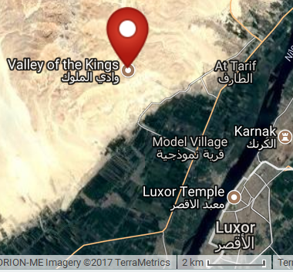

Fig. 4. Map of the location of KV.7.

**Cultural Affiliation:** New Kingdom, 19th Dynasty

**Medium:** replica, plaster of Paris; original, limestone.

**Dimensions:** H 18 cm; L 13 cm; T 3.80 cm **Weight: n/a**

**Provenance: Tomb KV.7 Valley of the Kings; Louvre Museum, acc. no. N522.**

**Condition:** replica

**Discussion:**

Both sides of this votive stele reflect the symbolic significance of the sign of *akhet* N27 (Gardiner 1957, N27) the sun rising on the horizon between two mountains.

The obverse panel implies that the royal child is Ra’s chosen one being born "like the morning Sun" that rises as the creative force incarnated in the figure of the emergent king who creates like Ptah.

The reverse panel depicts the god Ptah, the Great Craftsman, who could bring forth new life through both thought and word, and who was to be emulated by Ramesses II in encouraging sculptors to carve deities and engineers to build monumental temples and buildings such as the vast tomb complex known as the Ramesseum at Thebes, the temples at Abu Simbel, the hall at Karnak, and the complex at Abydos.

**References:**

Andrey, G., M. H. Rutschowscaya, and C. Ziegler. 1997*. L'Egypte au Louvre*. Paris: Hachette, p. 144, 254, notice 65.

Brier, Robert. 1994. *Egyptian Mummies: Unravelling the Secrets of an Ancient Art*. New York: William Morrow & Co. Inc.

Gabriel, Richard A.2003. *The Great Armies of Antiquity.* Praeger Publishers.

Gardiner, A.H. 1957. *Egyptian Grammar: Being an Introduction to the Study of Hieroglyphs*. 3rd Ed. Oxford: Griffith Institute.

Kitchen, Kenneth. 1983. Pharaoh Triumphant: The Life and Times of Ramesses II, King of Egypt. London: Aris & Phillips.

Leblanc, Christian. 1997. "The Tomb of Ramesses II and Remains of his Funerary Treasure," *Egyptian Archaeology*; 10 (1997): 11-13.

Reeves, N., & Wilkinson, R. H. 1996. *The Complete Valley of the Kings*. London: Thames and Hudson.

Siliotti, A. 1996. *Guide to the Valley of the Kings and to the Theban Necropolises and Temples.* Cairo: A. A. Gaddis.